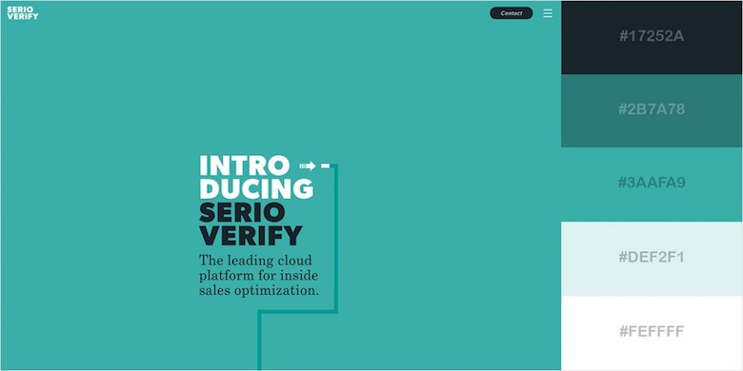

<https://preview.themeforest.net/item/sandbox-modern-multipurpose-bootstrap-5-template/full_screen_preview/32441701?_ga=2.46692391.1413575400.1669028669-924170147.1669028669>

<https://sandbox.elemisthemes.com/contact.html>